

**NAME:** KASHIF MAJID DAR

**DIVISION:** CS B1

**PRN:** 19070122084

***ASSIGNMENT 10***

***AIM:*** WRITE A C PROGRAM USING FUNCTIONS TO ACCEPT TWO STRINGS FROM THE CONSOLE AND PERFORM THE **FOLLOWING OPERATIONS (**USING BUILT-IN FUNCTIONS):

1. COMPARE THE STRINGS: EQUAL/NOT EQUAL

***SOURCE CODE:***

#include <stdio.h>

#include <stdlib.h>

#include <string.h>

/* run this program using the console pauser or add your own getch, system("pause") or input loop */

main() {

char s[1000],a[1000];

printf("enter string:");

scanf("%s",s);

printf("your 1st string is %s",s);

printf("\nenter string:");

scanf("%s",a);

printf("\nyour 2nd string is %s",a);

if(strcmp(s,a)==0)

printf("\n%s and %s are equal\n",s,a);

else

printf("\n%s and %s are not equal\n",s,a);

}

***OUTPUT:***

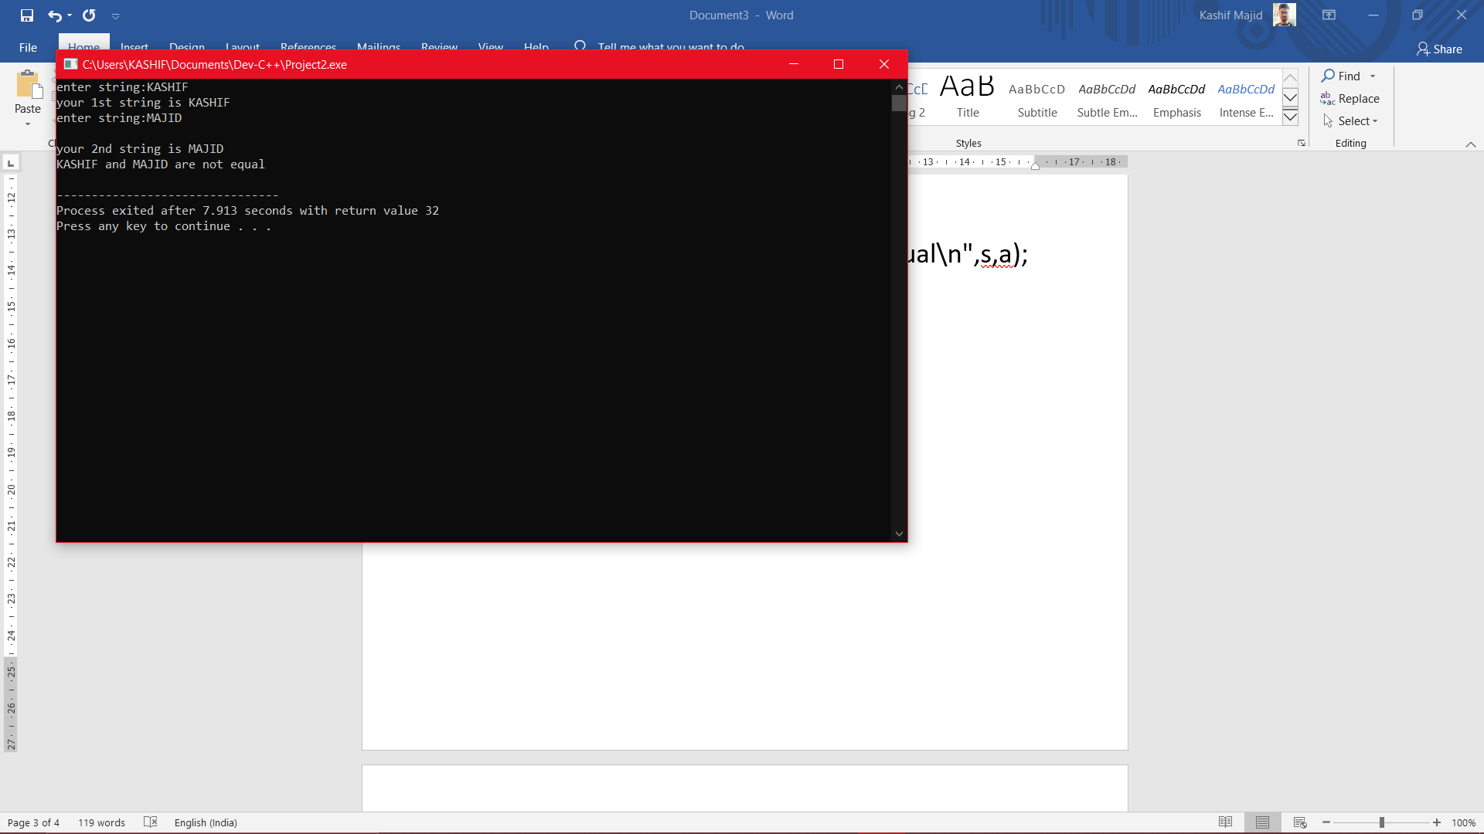

1. FIND THE LONGER STRING.

***SOURCE CODE:***

#include <stdio.h>

#include <stdlib.h>

/* run this program using the console pauser or add your own getch, system("pause") or input loop */

int main() {

char a[100],b[100];

printf("enter string 1:");

gets(a);

puts(a);

printf("enter string 2:");

gets(b);

puts(b);

if(strlen(a)>strlen(b))

printf("%s is longer string",a);

else

printf("%s is longer string",b);

return 0;

}

***OUTPUT:***

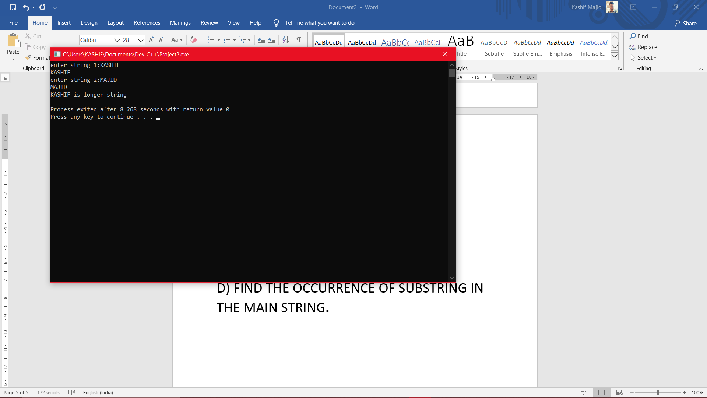

1. CONCATENATE TWO STRINGS

***SOURCE CODE:***

#include <stdio.h>

#include <stdlib.h>

#include <string.h>

/* run this program using the console pauser or add your own getch, system("pause") or input loop */

int main() {

char a[100],b[100];

printf("enter string 1:");

gets(a);

puts(a);

printf("enter string 2:");

gets(b);

puts(b);

strcat(a,b);

printf("concatenated string is %s",a);

return 0;

}

***OUTPUT:***

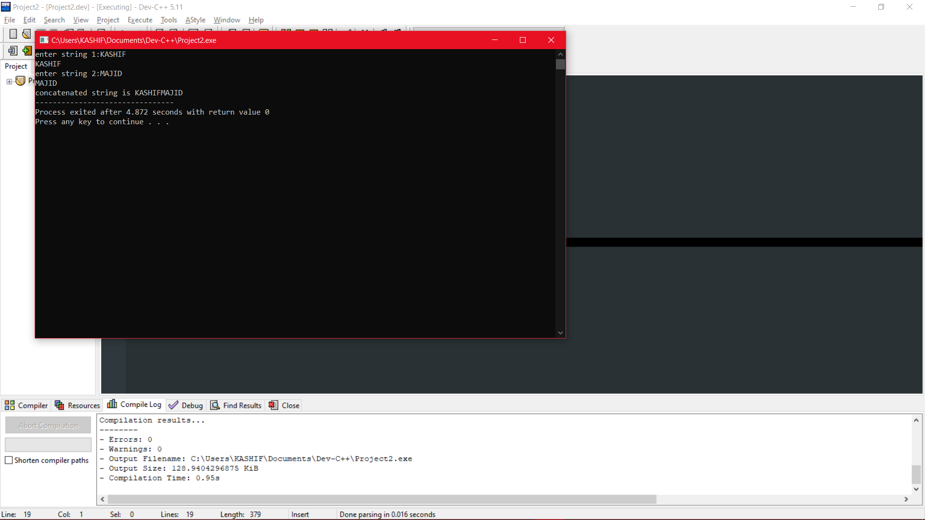

D) FIND THE OCCURRENCE OF SUBSTRING IN THE MAIN STRING**.**

***SOURCE CODE:***

#include <stdio.h>

#include <stdlib.h>

#include <string.h>

/* run this program using the console pauser or add your own getch, system("pause") or input loop */

int main() {

int i,j=0,k=0;

char a[60],b[30];

printf("enter string 1:");

gets(a);

puts(a);

printf("enter string 2:");

gets(b);

puts(b);

for(i=0;i<strlen(a);i++)

{

j=0;

if(a[i]==b[j])

{

while(j!=strlen(b))

{

if(a[i+j]!=b[j])

break;

else

j++;

}

if(j==strlen(b))

{

printf("%s found in %s",b,a);

k=1;

break;

}

else

printf("%s is not found in %s",b,a);

}

}

}

***OUTPUT:***

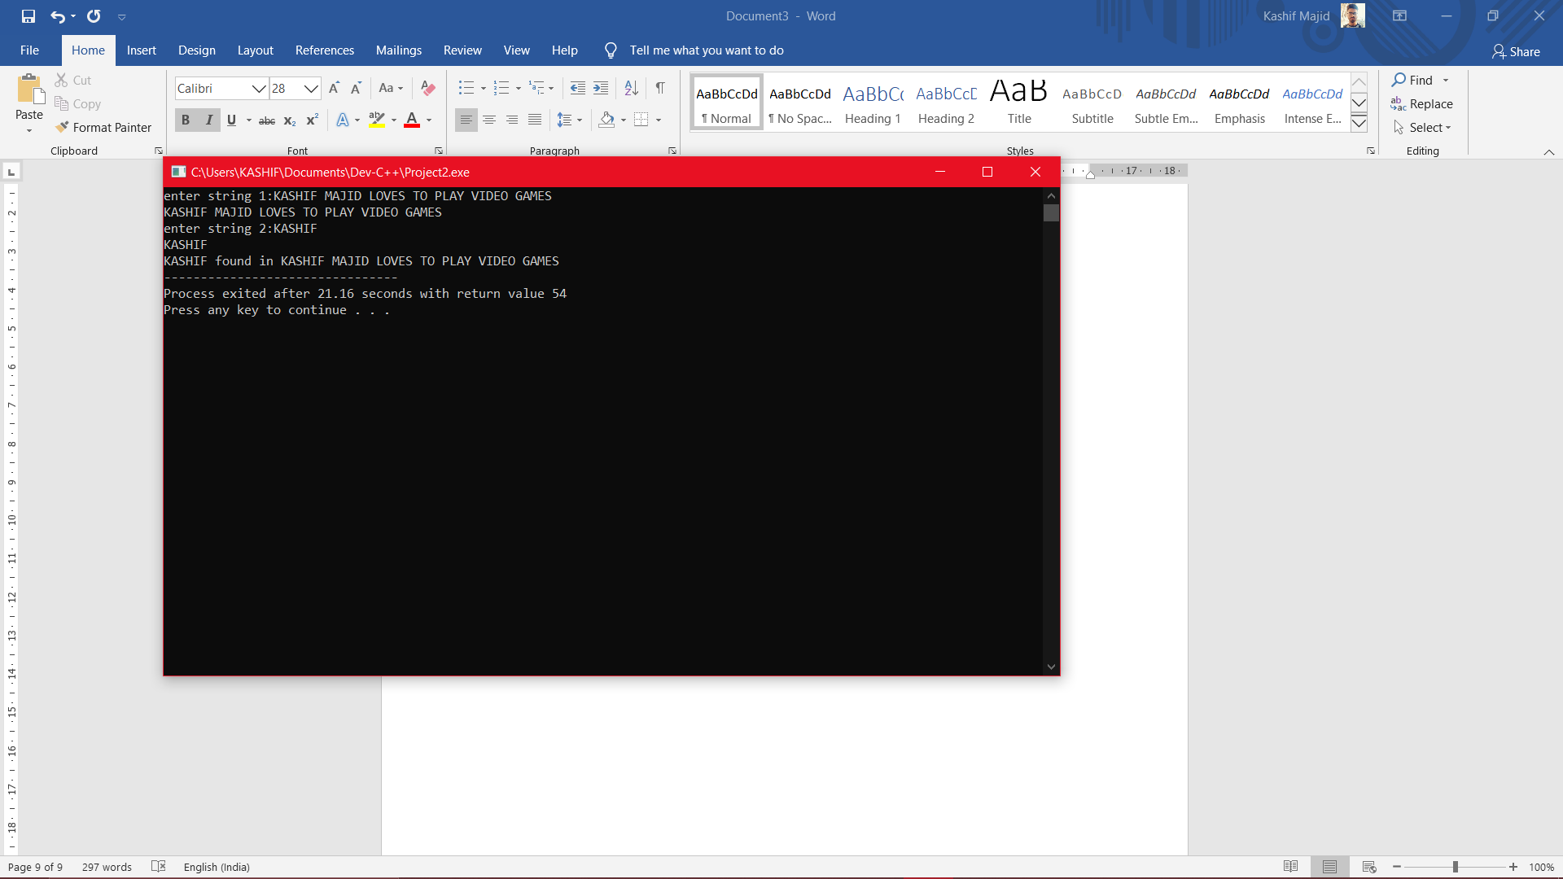

***CONCLUSION*:** FROM THIS EXPERIMENT I LEARNED TO USE BUILT-IN FUNCTION IN STRINGS.